2.5 logic view of the system

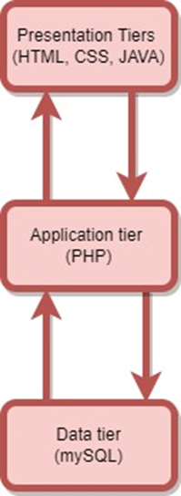

Fig no :3 logical view of the system.

Our Cruise line management system is split into three logical and physical computing tiers, as shown in the above picture. Each tier has its own infrastructure and may be independently updated as needed to meet the system's requirements and needs. Read on for an explanation of each:

i) Presentation Tier is the layer between the underlying system and the user's browser. HTML, CSS, and JavaScript are used throughout this system to present data to and receive input from users.

ii) The Application Tier is the logical or intermediate layer of our system, and it is responsible for processing the data acquired by the Presentation Layer and mediating the communication between the Presentation Layer and the Data Layer. We have to choose PHP as our system's programming language because it allows us to create applications that run smoothly and quickly.

iii)Data Tier—also called the database tier of the system, this is where all of the data handled by the application is stored and managed in a scalable, high-performance manner using the My SQL database management system.